Interfaith Volunteer Caregivers

of Clark County, Inc.

16th Annual
Festival of Thanks

Sunday, October 12, 2014
Calvary Lutheran
Neillsville, Wisconsin

A Community Celebration of Volunteer Care giving

The Interfaith Board of Directors

A Board of Directors, a group of eight members who meet monthly to promote policy, growth and the direction of the program, governs the Interfaith Caregivers of Clark County, Inc. currently serving on the Board:
President Judy Morrow
Vice President Peggy Erickson
Secretary Mary Sladich
Treasurer Betty Opelt
Members Doris Bakker
Kate Linquist
Sandy Fritz
Eric Englebretson
Rhonda Fulwiler

Contact Information:
Interfaith Volunteer Caregivers of Clark County
Po Box 222
Neillsville, WI 54456-0222
Phone: 715-743-2885

“Change of Seasons”

by Judy Morrow

It is the time of the year when the leaves are falling and lawns need to be raked. October 25th is the date of the Change of Seasons Program in Neillsville and Loyal. St. Mary’s Justice and Peace Committee, Clark County Aging Department, Interfaith Volunteer Caregivers of Clark County and area churches sponsor this program.

What is Change of Seasons? For those who have never participated in the program, it is a time for community volunteers to help our deserving Senior Citizens with those “Change of Season” odd jobs. This happens each spring and fall with the help of many community volunteers.

Volunteers will meet on October 25th at 8:00 a.m. at United Church of Christ in Neillsville and the Trinity Lutheran Church in Loyal for breakfast made by the community. We begin the day with a short prayer for blessings on the day. Then the volunteers are grouped with a leader and a list of chores to accomplish. Most groups are done by noon and can enjoy a lunch together at United Church of Christ in Neillsville.

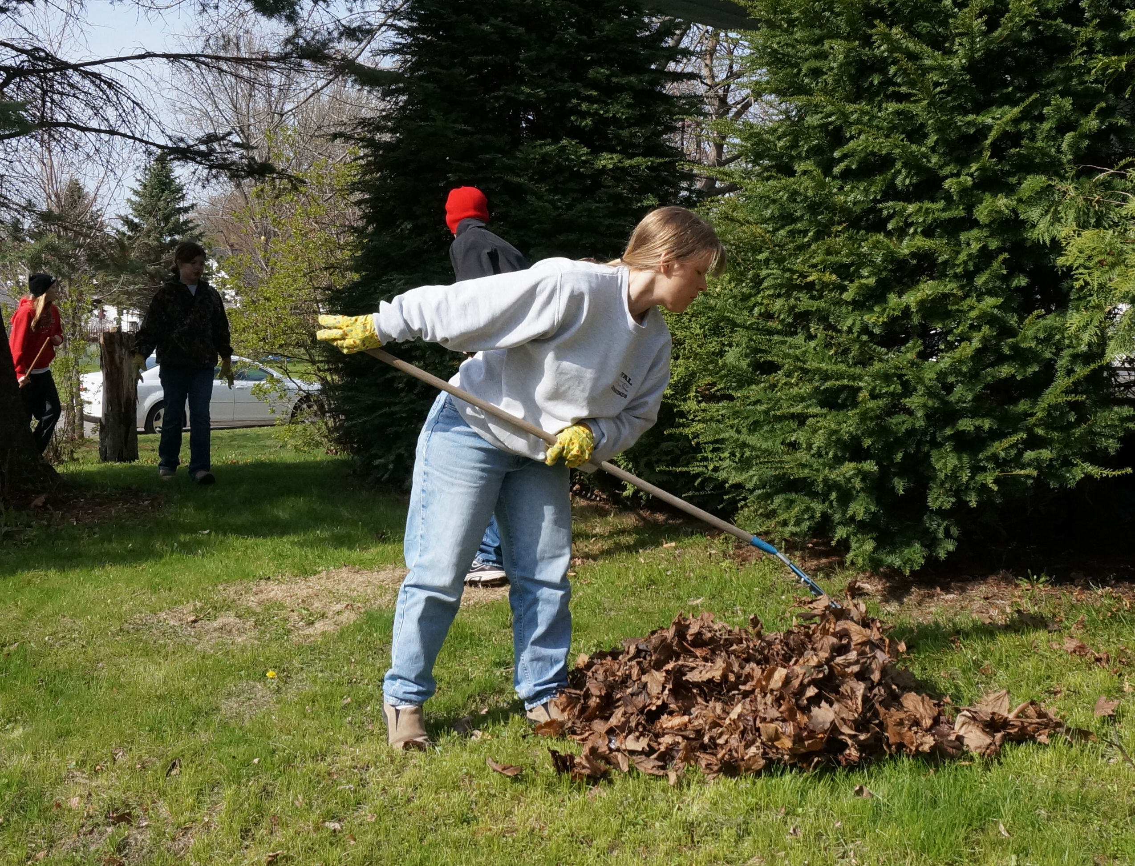
If you can give a morning of your time to help us help our elderly it would be so appreciated. Come as a family. Come as a youth group. The more volunteers the more we can help and the more fun we will have.

If you need your lawn raked or other jobs please feel free to call 715-743-2885 and have your name put on the list. Certainly if you have questions call, volunteers are here to help you.

Change of Season Helpers
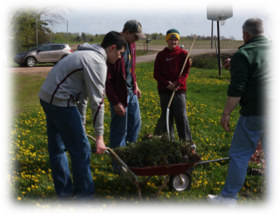
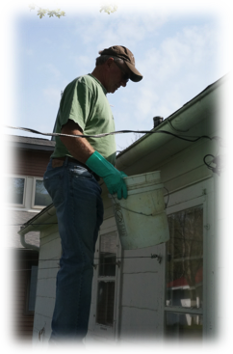
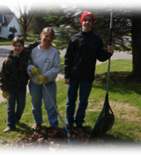
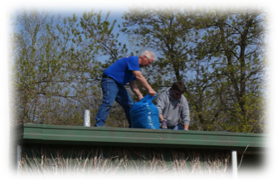

Change of Season Helpers
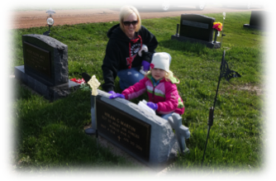
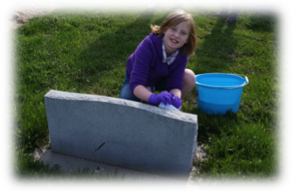
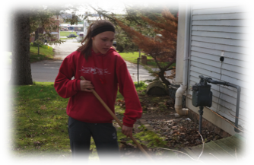
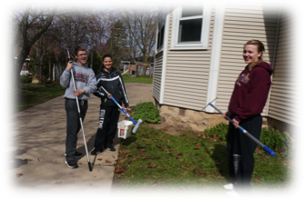

A Commemorative Gift

Please support the Interfaith Volunteer Caregivers program as they contribute to make a difference in the lives of the elderly neighbors (and those with disabilities in the 50 age range) throughout Clark County. Your donation of “neighbor helping neighbor” is much appreciated.

Please accept my contribution of $

Donor’s Name:

Address:

City, State & Zip:

In Memory of:

In Honor of:

Occasion:

Please make your check payable to:

IVC of Clark County
PO Box 222
Neillsville, WI 54456-0222

Program Agenda

Prelude Music by Ashley Volovsek

Welcome Pastor Lowell Bolstad,
Calvary Lutheran

Neillsville High School
Concert Choir Directed by Wendell Attoe
Accompanied by Jodi Rueth

Kyrie Composed by Brian Lewis

Angel Breathing Out Composed by Alisa Bair

Lord, I Know I Been Changed Arranged by Larry Shackley

Congregational Hymn
“How Great Thou Art” Accompanied by Ashley Volovsek

(If able, please stand. Words are located on following page)

Offertory Music by Ashley Volovsek

Clark County Choraliers Directed by Donna Olson
Accompanied by Jodi Rueth

Music, Lead the Way Composed by Laura Farnell

You Have Wings to Fly Composed by Jerry Estes
& Greg Gilpin

Joshua! (Fit the Battle of Jericho) Arranged by Kirby Shaw

Steal Away Arranged by Brazeal Dennard

Calvary Lutheran Directed by Mary Heineck
Accompanied by Jodi Rueth

Surely the Presence of the Lord
Is In This Place Composed by Lanny Wolfe
Arranged by Jack Schrader

Lord of Mercy, Lord of Grace Composed by Stan Pethel

Thanks Be to God! Composed by Nancy & Don Besig

Tim Scaletta
Engine Room Composed by James Campbell

Reception Immediately following in the Fellowship Hall

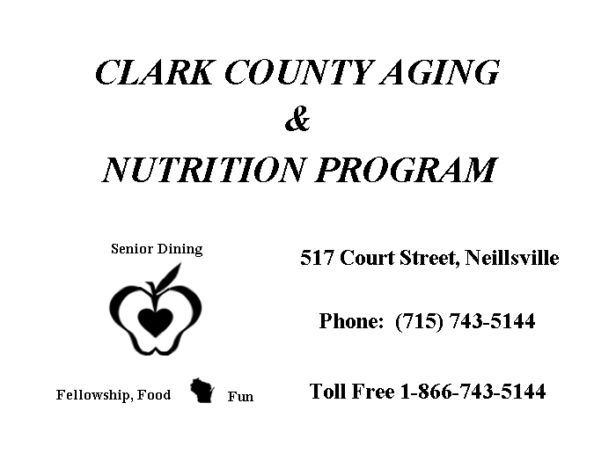

Congregational Hymn

“How Great Thou Art”

O Lord my God, When I in awesome wonder,
Consider all the worlds Thy Hands have made;
I see the stars I hear the rolling thunder,
Thy power throughout the universe displayed.

Refrain:
Then sings my soul, My Savior God, to Thee,
How great Thou art, How great Thou Art.
Then sings my soul, My Savior God, to Thee,
How great Thou art, How great Thou art!

When through the woods, and forest glades I wander,
And hear the birds sing sweetly in the trees.
When I look down, from lofty mountain grandeur
And see the brook, and feel the gentle breeze.

Refrain:

And when I think, that God, His Son not sparing;
Sent Him to die, I scarce can take it in;
That on the Cross, my burden gladly bearing,
He bled and died to take away my sin.

Refrain:

When Christ shall come, with shout of acclamation,
And take me home, what joy shall fill my heart.
Then I shall bow, in humble adoration,
And then proclaim: “My God, how great Thou Art!”

Refrain:

History of Interfaith Volunteer Caregivers of Clark County, Inc.

As a “Faith in Action” 501c3 non-profit organization, the Interfaith Volunteer Caregivers of Clark County, Inc. established mission was “Helping elderly neighbors maintain independent living throughout Clark County.”
In 1984, twenty-five interfaith coalitions (churches, temples, and synagogues) began to experience the strength of working together in a ministry of volunteer care giving. Aware of the great unmet needs of so many in our country, a national federation was formed with a single purpose: to assist congregations of all faiths to come together to provide an effective volunteer care-giving ministry. Today, there are over 1600 Interfaith Volunteer Caregiver and “faith in Action” projects across the United States, Washington D.C. and Guam. Startup funds were provided by grants from the Robert Wood Johnson Foundation.
The Clark County program was formed in June of 1992 when members of the Neillsville Ministerial Alliance noticed an increasing amount of unmet needs coming in from various areas of Clark County. Between 1992 and June of 1997, there were continued surveys and meetings among the 15 coalition members to address the question of the needs in Clark County.

History of Interfaith, Cont.

When it was proven that both the leadership support and needs were present, a Board of Directors was formed and a Program Director was hired. Edi Peterson served as director until September 1998 at which time Dixie Schroeder became director. In December of 2006, Sharon Hendrickson became the director. The Articles of Incorporation dated March 19, 1998. Reverend James Gordon, the initial president, signed them. Judy Morrow is our current president.
The coalition applied for a $25,000 Robert Wood Johnson Foundation grant. This 18-month grant was awarded in October of 1997 to start a volunteer care-giving ministry in Clark County. The Interfaith continues to utilize grants, congregational support, individual donations, and fundraising as a means to support the program.
Most importantly, the Interfaith Volunteer Caregivers of Clark County, Inc. continues to serve our elderly neighbors utilizing countywide volunteers who give so graciously. While many hours of support and miles logged each month by the volunteer, there is no way to record “the extra mile” they go to make a difference in the lives of our elderly population.

History of Interfaith, Cont.

Indeed, in Clark County, Interfaith is the single-most volunteer organization to provide needed services to the receiver. Without these extra special people in our county, our elderly would need to pay for services or relocate to another type of living arrangement.
Check out our website:
www.volunteersinfaith.org

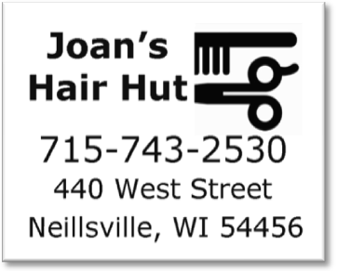
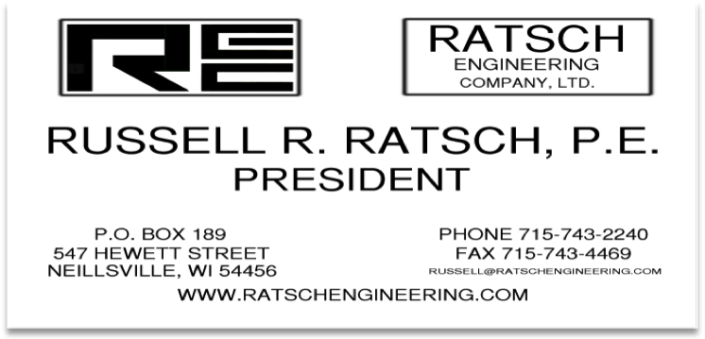
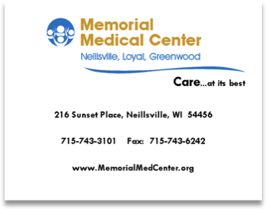
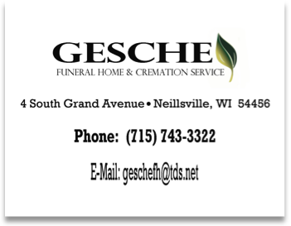

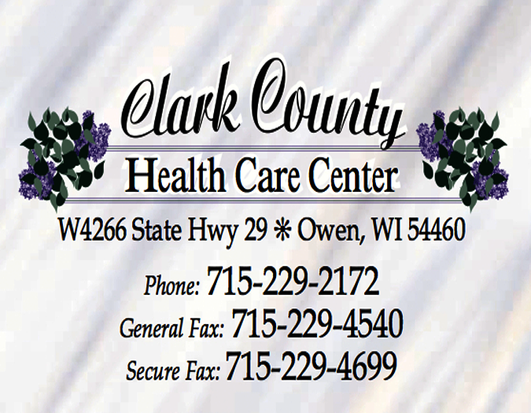

Thank You

- Pastor Lowell Bolstad and Calvary Lutheran Church for their gracious hospitality to the Clark County community.

- Each and every congregation in Clark County for your continued support of Interfaith activities and needs.

- Area businesses that purchased advertisement space in today’s program booklet.

- Directors, accompanists, and vocalists for sharing your time and talents today.

- Everyone who donated, prepared, or served the luncheon.

- The Interfaith Board of Directors for serving as ushers, providing refreshments, and for your dedication and guidance.

- Registered Volunteers…You are the backbone of the Interfaith organization. Without you, some of our older residents and neighbors would not be able to remain in their homes.

The Interfaith Volunteer Caregivers of Clark County thanks each and every one of you for joining us this afternoon. Please join us in the fellowship hall for refreshments.

Have a Safe Trip Home!

